Successful accomplishment of Chlorine Leakage Control at Industrial Area, Bhopal

Date and Time: 05th March 2014 / 1715 hours

Accident Site : M/s Laxmi Sales Agency, 7/7, Sector-H, Govindpura Industrial Area, Bhopal, Owned by Shri Ashok Patel.

Scenario : Chlorine Leakage from Cylinder during cutting.

Incident Reporting : The ERC received information through Regional Office, MPPCB, Bhopal at 1915 hrs that a profile cutting industry received a chlorine cylinder in scrap material through auction by Metal Scrap Trade Corporation.

Action by ERC : The ERC I/c immediately moved to the site at arounf 1930 hrs and while on way informed to the fire brigade officials, CISF personnel and DIHS officials. On reaching the spot a water curtain was established near the chlorine cylinder with the help of CISF team. Another CISF man, wearing the SCBA and carrying Dragon search light, was asked to trace and pinpoint the whole in the cylinder to decide further action. Based on the feedback a wooden peg of about 1" was carved and the hole was plugged. The situation seemed to be under control and the leakage seemed to have been stopped. The ERC I/c and the Scientist, Regional office, MPPCB returned from the site at around 2200 hrs.

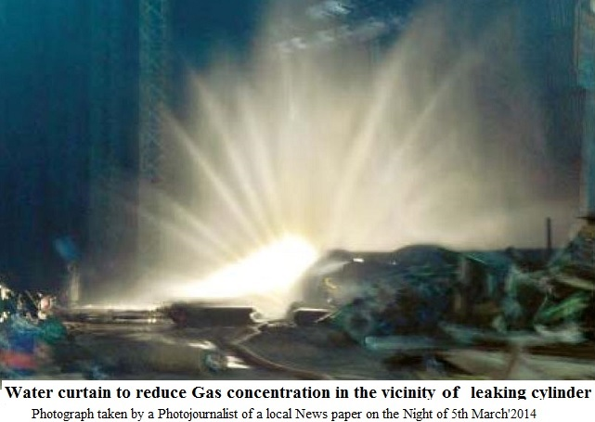

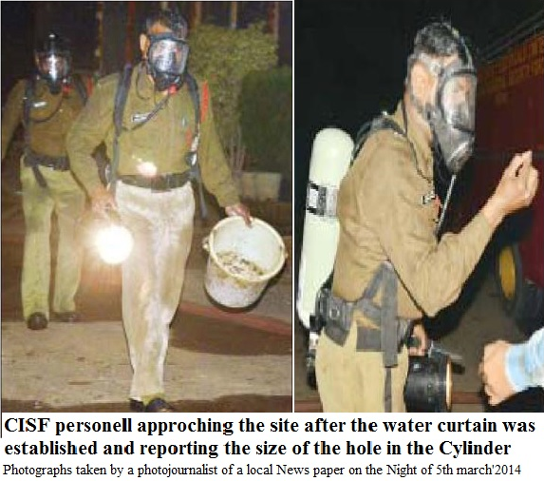

Next morning, ie. 06/03/2014, when ERC scientist visited the site to take stock of the situation following the leakage of chlorine gas from a scrapped cylinder in the premises yesterday which created panic in the area and affected the workers in the surrounding industries. There was pungent and penetrating smell of chlorine inside the premises at the time of inspection. The cylinder was lying in open on soil surface. Fortunately there was ice formation on the outer surface of the cylinder forming a good insulation which helped in reduction of vaporization by restricting transmission of external heat into the cylinder. The ice formation indicates the presence of liquid chlorine inside the cylinder which would have drawn heat from inside the cylinder and lowers the temperature and condensated the air on cylinder surface forming the ice. The chlorine emission rate increased due to rise in ambient temperature as the Sun advanced and therefore this was informed to the ERC, The district administration, Nagar Nigam chief engineer and BHEL officials were requested to send the help respond the situation. Communication was also made to 108 Ambulance to reach the site. Since the chlorine concentration started rising vary rapidly it was decide to get the leaking gas nutralised on the spot asany attempt to shift it seemed counter productive and hazardous and the nearest help capable to deal chlorine issue was at Nagda about 300 kilometers awaywhich would have taken at least six more hours. However, a timely technical guidance was provided on phone by Mr. H.S. Sehgal, Chlorine Expert, Vadodara (mob. 09825303079) proved to be very useful during entire operation which lasted for about 6 hours.

In the given situation a JCB machine was called to excavate a pit to accommodate the leaked cylinder for nullification. The cylinder was lowered vertically in the pit with the help of hydra machine and was showered with lime and caustic solution. The level of lime and caustic solution for speedy absorption and neutralization was maintained in the pit as some quantity was seeping underground to the nearby drain. Precaution was taken to ensure that the cylinder does not float in the pit by putting some extra weight on the top. Looking to the quantity of sodium hydroxide and lime consumed in the operation, the quantity of chlorine in the cylinder would have been not less than 50 kg. About 50 kg sodium hydroxide and 500 kg of lime was used in the form of slurry during the neutralization operation. Since it was a scrapcutting and fabrication unit, it did not have any safety equipment, neutralizing system or cylinder handling machines, therefore, everything required for tackling the crisis was to be pooled up from outside.

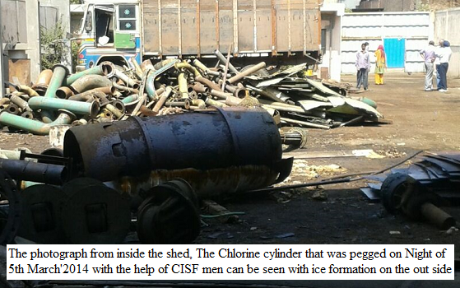

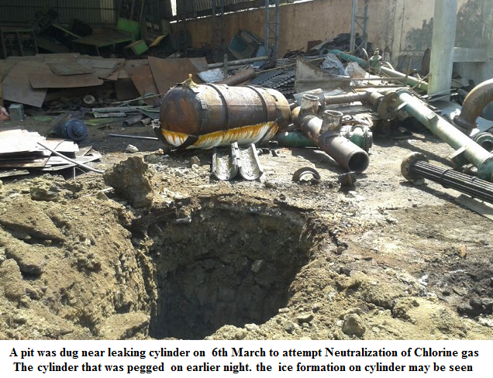

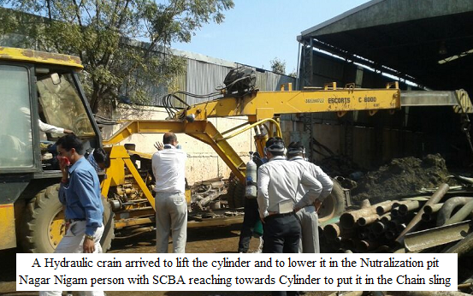

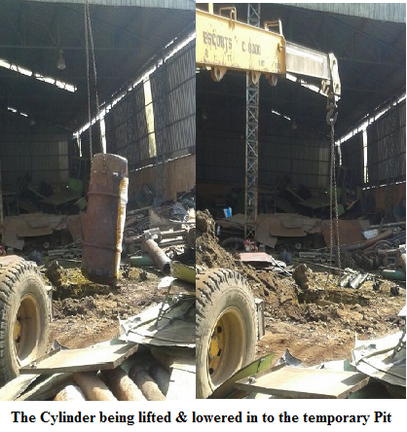

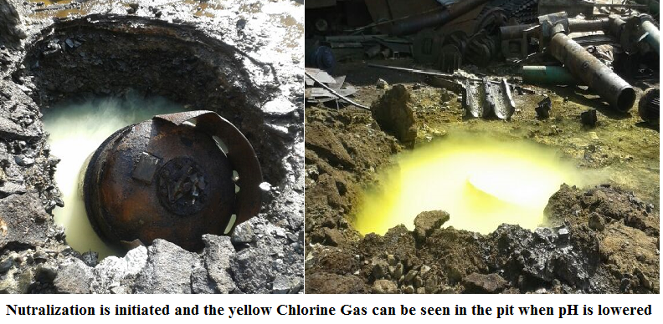

The Neutralization operation of Chlorine was accomplished successfully by under the supervision of Emergency Response Centre, MPPCB.

